**Quipu QA Task Report**

QA: Hristina Bozhinovska

Date: 29.10.2024

**Task Part 1: Test cases for the search feature**

**Test Case ID:** TC001

Title: Search with Valid Fashion Item

Precondition: User is on the homepage of the Automation Practice site.

Steps:

1. Enter a valid search term (e.g., "dress") in the search bar.
2. Click the "Search" button (magnifying glass icon).

Expected Result: The search results page displays a list of dresses with images, prices, and descriptions.

**Test Case ID:** TC002

Title: Search with Empty Input

Precondition: User is on the homepage of the Automation Practice site.

Steps:

1. Leave the search bar empty.
2. Click the "Search" button (magnifying glass icon).

Expected Result: The search results page displays an error message stating " Please enter a search keyword"

**Test Case ID:** TC003

Title: Search with Invalid Fashion Term

Precondition: User is on the homepage of the Automation Practice site.

Steps:

1. Enter an invalid search term (e.g., "invaliditem123") in the search bar.
2. Click the "Search" button (magnifying glass icon).

Expected Result: The search results page displays a message indicating " No results were found for your search "invaliditem123"”

**Test Case ID:** TC004

Title: Autocomplete Suggestions

Precondition: User is on the homepage of the Automation Practice site.

Steps:

1. Begin typing a valid search term (e.g., "dress") in the search bar.

Expected Result: Autocomplete suggestions related to "dress" appear below the search bar.

**Test Case ID:** TC005

Title: Search results sorting for dresses

Precondition: User is on the search results page of the Automation Practice site.

Steps:

1. Enter a valid search term (e.g., "dress") in the search bar.
2. Click the "Search" button (magnifying glass icon).
3. Select a sorting option (e.g., "Price: Highest first").

Expected Result: The search results display dresses sorted according to the selected sorting order.

**BUG REPORTS:**

1. Visual Bug:

**Title:** Outdated Twitter Logo in Footer

Bug ID: 001

Environment:

URL: <http://www.automationpractice.pl/index.php>

Browser: Chrome Version 130.0.6723.70

Operating System: Windows 11

Precondition: User is on the homepage of the Automation Practice site.

Steps to Reproduce:

1. Open the Automation Practice website.
2. Scroll down to the footer of the page.

Actual Result: The footer displays the old Twitter logo instead of the current "X" logo.

Expected Result: The footer should display the updated "X" logo instead of the Twitter logo.

Severity: Minor

Priority: Medium

Screenshot/Attachment:

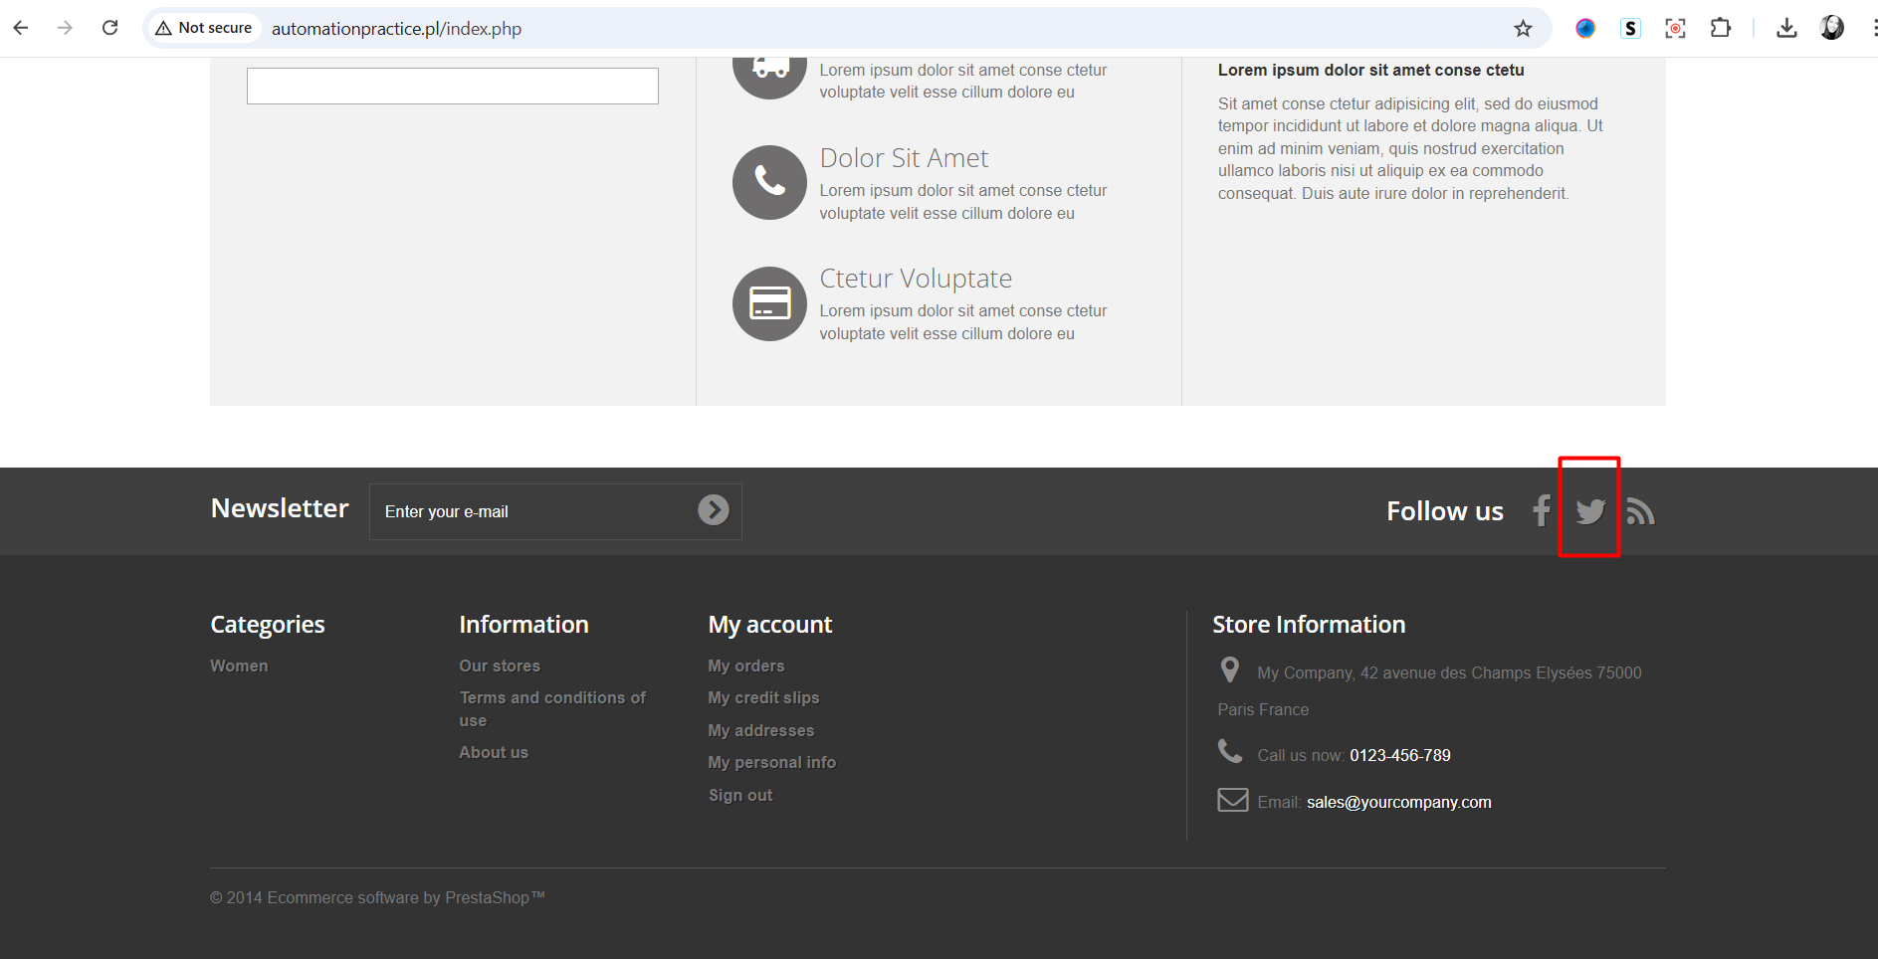

Additional Notes: This may affect user perception of the brand and the relevance of social media links.

1. **Functional Bug**

**Title:** Out of Stock Dresses Displayed After Filtering for In-Stock Items

Bug ID: 002

Environment:

URL: <http://www.automationpractice.pl/index.php>

Browser: Chrome Version 130.0.6723.70

Operating System: Windows 11

Precondition: User is on the dresses PLP page.

Steps to Reproduce:

1. Navigate to the dresses section on the Automation Practice website.
2. Sort the items by clicking on "In Stock" items.
3. Observe the displayed results.

Actual Result: The sorted results still display dresses that are out of stock.

Expected Result: The sorted results should only display dresses that are currently in stock.

Severity: Major

Priority: High

Screenshot/Attachment:

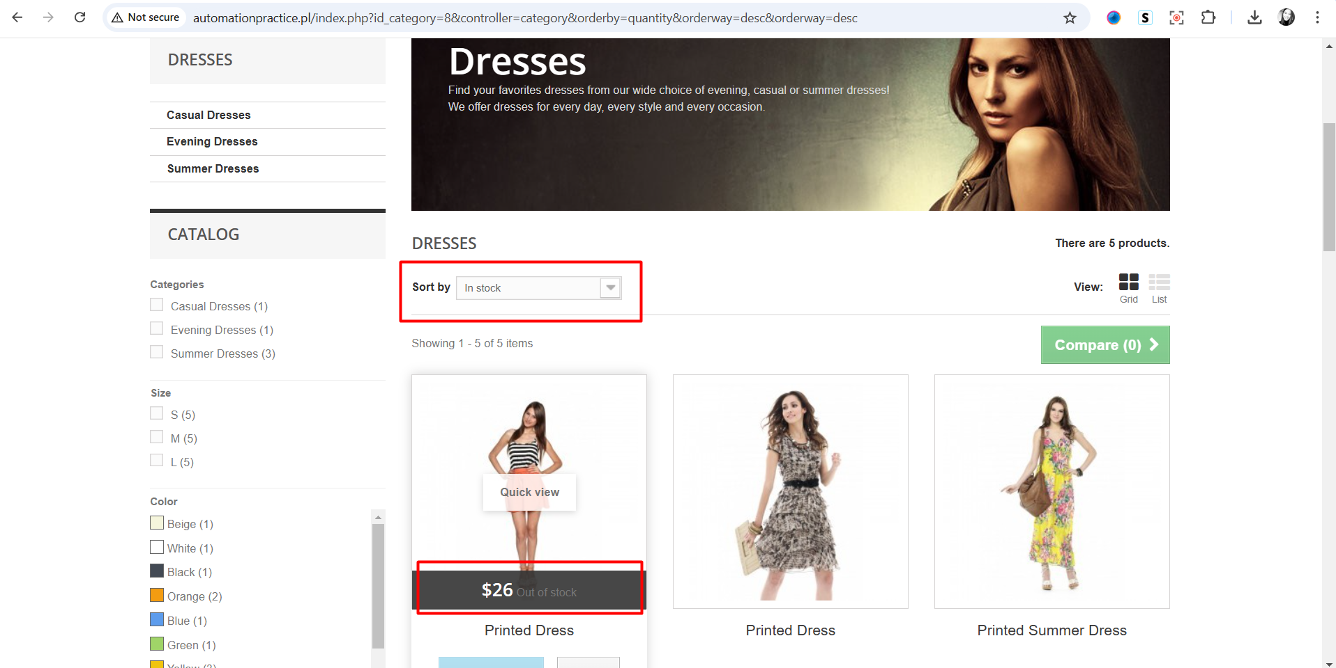

Additional Notes: This issue may lead to customer frustration and a negative shopping experience as users expect to see only available items.

1. **Functional Bug**

**Title:** Incorrect Search Results for "Summer Dress"

Bug ID: 003

Environment:

URL: http://www.automationpractice.pl/index.php

Browser: Chrome Version 130.0.6723.70

Operating System: Windows 11

Precondition:

User is on the homepage of the Automation Practice site.

Steps to Reproduce:

1. Navigate to the homepage of the Automation Practice website.
2. Enter the search term "summer dress" in the search bar.
3. Click the "Search" button (magnifying glass icon).

Actual Result:

The search results display a T-shirt item instead of relevant summer dresses.

Expected Result:

The search results should display products relevant to the search term "summer dress."

Severity: Major

Priority: High

Screenshot/Attachment:

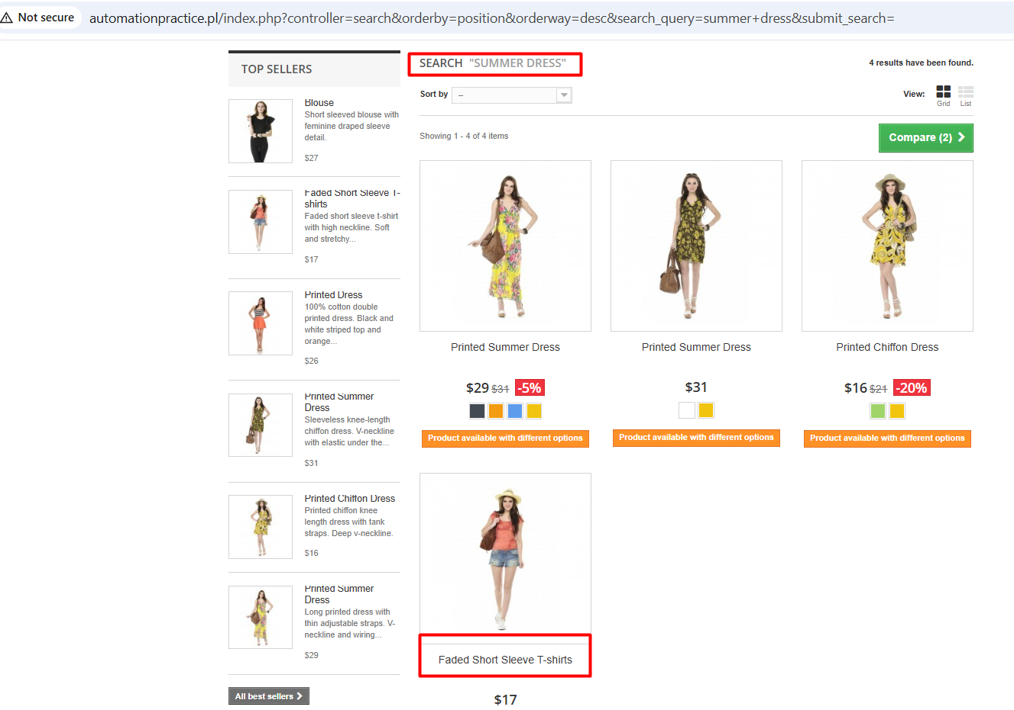

Additional Notes:

This issue may lead to customer confusion and dissatisfaction as users expect to find products that match their search criteria.

**Summary of Work Completed**

During the allotted three-hour timeframe, I dedicated my efforts to the following:

**Test Cases:** I successfully crafted 5 test cases focused on the search feature of the Automation Practice website. Each test case was designed to thoroughly validate expected behaviors, showcasing my attention to detail and commitment to quality.

**Bug Reports:** I identified and documented 3 bug reports (2 functional and 1 visual bug) related to the website’s functionality and user experience. These reports highlight critical issues that could impact user experience, demonstrating my proactive approach to improving the platform.

**End-to-End Automation Testing:** I dedicated considerable effort to creating two automation tests using Selenium and Robot Framework in PyCharm. Although I encountered challenges with the ChromeDriver setup on my PC, I remained determined and worked diligently to troubleshoot the issues. Unfortunately, this impacted my ability to complete the remaining end-to-end automation scenario within the given time frame, and I acknowledge that these tests may not be flawless.

I am committed to further developing my automation skills and am eager to learn from this experience. I believe my efforts demonstrate my strong dedication to the role and my enthusiasm for making a meaningful contribution to the team.

**Report Submitted:**

This report is submitted on 29.10.2024. If further clarification or additional information is required, please feel free to contact me anytime via email or phone.